https://www.amazon.com/Innovators-Dilemma-Revolutionary-Change-Business/dp/0062060244
 | | | 4.3 out of 5 stars | | | 242 customer reviews

Images
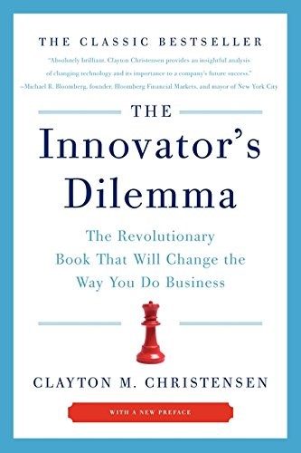

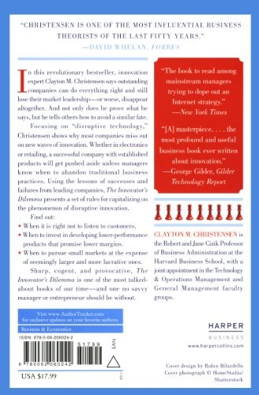

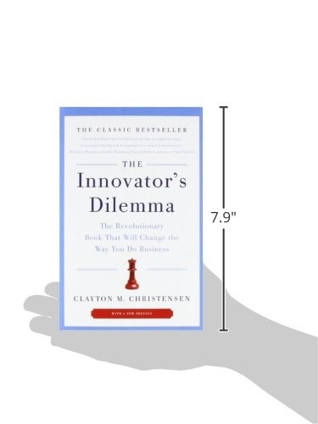

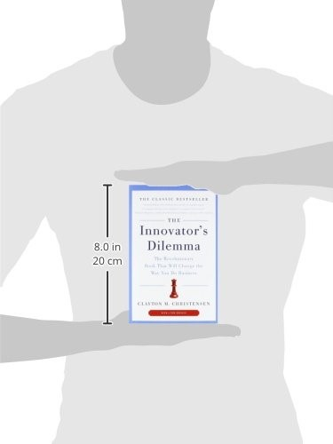

Book Description
“Absolutely brilliant. Clayton Christensen provides an insightful analysis of changing technology and its importance to a company’s future success.”—Michael R. Bloomberg
“This book ought to chill any executive who feels bulletproof —and inspire entrepreneurs aiming their guns.”—Forbes
The Innovator’s Dilemma is the revolutionary business book that has forever changed corporate America. Based on a truly radical idea—that great companies can fail precisely because they do everything right—this Wall Street Journal, Business Week and New York Times Business bestseller is one of the most provocative and important business books ever written. Entrepreneurs, managers, and CEOs ignore its wisdom and its warnings at their great peril.

Aus <https://www.amazon.com/Innovators-Dilemma-Revolutionary-Change-Business/dp/0062060244>

